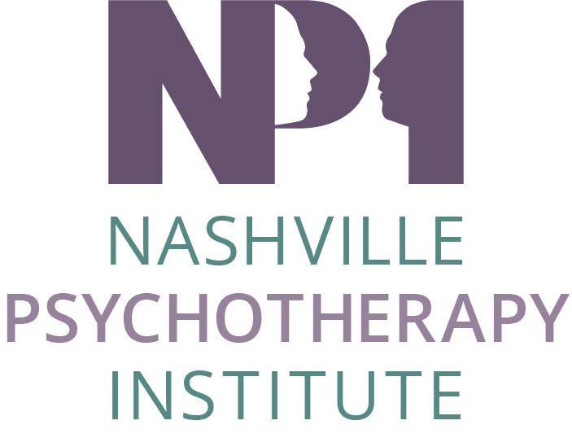
NPI Scholarship Guidelines
The Nashville Psychotherapy Institute was founded by a group of psychotherapists from various disciplines committed to providing continuing education and personal growth opportunities to mental health professionals in the Nashville community. In support of this mission, NPI offers scholarships to current NPI Members and other individuals who otherwise would not be able to attend NPI workshops, symposiums, and/or conferences.
Event Title: Events include any Educational NPI Sponsored Event (Workshop)
Application Deadline: The Advertised Early Registration Date per Event.
Scholarship Awards are based on:
- The amount of funds allotted for distribution;
- Submitting application during the stated application time period.
Other Considerations:
- NPI members are given preference.
- Non-member applicants must be nominated and/or recommended by a current NPI member. The NPI member nominating an applicant must complete the application on behalf of the applicant (non-NPI member).
- Scholarships are awarded to cover part or all of the base Event fee and do not include pre- or post- conference workshops, room and board, or transportation.
Application Procedure:
Email all applications to the address listed below.
- Complete and submit this application as an attachment.
- Send completed application to npischolarships@gmail.com
Scholarship forms will be accepted after publication of the specific event.
Deadline for receipt of the application is the Early Registration Date for each event (Workshop, etc.).
All scholarship applicants will be notified of decision as soon as possible.

NPI Scholarship Application
1. Name of Event:
2. Scholarship Applicant Name:
3. NPI Member: ___ yes ____ no
4. Name of person completing this application:
5. Applicant Phone/fax:
6. Applicant E-Mail:
7. NPI Membership Category:
___Agency
___ Patron /Professional/ Sustaining
___ Professional/ Trainee
___Student
8. Assistance Requested (check all that apply):
___ Complete Registration Fee
___ Partial Registration Fee
___ Work Exchange (I would like to provide assistance to the NPI programming committee at this event in exchange for my registration fee).
Return Application by email to npischolarships@gmail.com.
You will be notified by email that your application has been received and whether it is approved or denied. All applications and scholarship awards will remain confidential.

